# Station 1 Current-carrying wires /10 marks

Questions:

1. Does the direction of the magnetic field predicted by the hand rule agree with your observations? Draw a diagram of the magnetic field around a current-carrying wire.

checkmark

Yes, the hand rule agrees with the observed magnetic field direction.

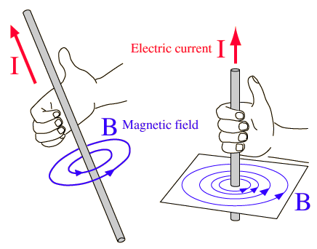

checkmark

* What is the purpose and function of using a compass in this activity?

checkmark

checkmark

The compass acts as a test magnet which indicates the direction of the induced magnetic field around a wire or through a solenoid.

**Station 2 Solenoid – electromagnet**

Questions:

1. Using the appropriate hand rule, does the direction of the magnetic field predicted by the hand rule agree with your observations? Draw a diagram of the magnetic field generated in a solenoid.

checkmark

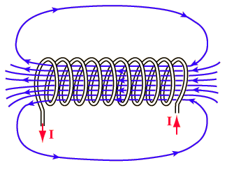The hand rule predicts the observed magnetic field direction.

checkmark

checkmark

1. Compare and contrast an electromagnet and a bar magnet.

checkmark

A bar magnet has a permanent magnetic field which is the result of aligned magnetic domains in the metal.

checkmark

An electromagnet has a field that is induced by current running around a coil of wire.

Both permanent and electro magnets have similar field patterns.

checkmark